(Approx. 411 words)

Secure Your Flash Drive Cap
By Fran Damratowski. Refurbishing SIG Leader, Chesapeake PC Users Group, MD
www.chesapeakepcusersgroup.org
refurbishing(at)chesapeakepcusersgroup.org

Obtained from APCUG with the author's permission for publication by APCUG member groups.

Have you ever misplaced your flash drive cap? No need to ever do that again. Secure it with a button. You will need
--a shirt button,
--some heavy thread such as carpet thread,
--double sided self-sticking adhesive mounting foam,
--double sided sticky tape, and
--some colorless nail polish.

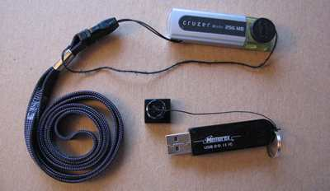

- Run the thread diagonally through two of the buttonholes and secure with a square knot.
- Place the knot on the top of the button not on the flat bottom of the button.
- Cut the thread long enough to secure it with enough play to remove the cap.
- Cut a small piece of the double-sided self-sticking adhesive mounting foam about the size of the button.
- Remove the backing from one side of the double-sided self-sticking adhesive mounting foam and place a small piece of the double-sided sticky tape on the sticky side of the double-sided self-sticking adhesive mounting foam. (The double-sided self-sticking adhesive mounting foam does not hold well without the sticky tape. The tape alone does not hold well either.)
- Securely attach the flat side of the button to the sticky tape.
- Trim the excess tape and foam using an x-acto knife.
- Remove the backing from the other side of the double-sided self-sticking adhesive mounting foam and place another piece of double sided sticky tape on the foam.
- Securely attach the button foam and tape to the flash drive cap.
- Secure the other end of the thread to the flash drive or lanyard.
- Leave enough play to easily remove the cap, but not get tangled.
- Use the colorless nail polish to secure the knots so they don’t become undone.
- After the nail polish dries trim the thread.

OR

You could go to your local photo shop and buy a $2+ button size lens cap keeper (or cap retainer) and modify it as needed. Most of them appear to come with elastic bands that are placed around the lens barrel as opposed to a leash that can be attached to another part of the camera.

This article has been provided to APCUG by the author solely for publication by APCUG member groups. All other uses require the permission of the author (see e-mail address above).

